**Matrix Factorization**

1)

Records vs Time

|  |  |  |  |  |
| --- | --- | --- | --- | --- |
| Records | 100 | 1000 | 10000 | 100000 |
| Time | 0.016 | 0.126 | 1.197640896 | 11.55890489 |

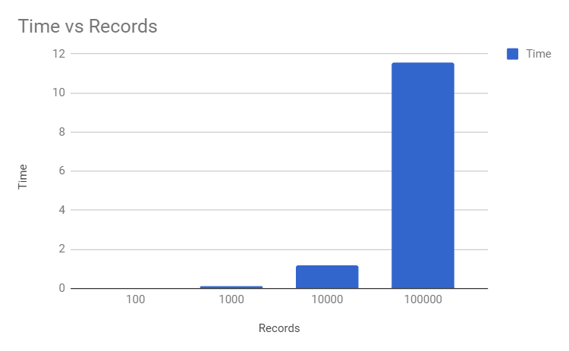

2)

Records vs Mean RMSE

|  |  |  |  |  |
| --- | --- | --- | --- | --- |
| Records | 100 | 1000 | 10000 | 100000 |
| Mean RMSE | 0.9 | 2.085 | 2.19 | 1.14 |

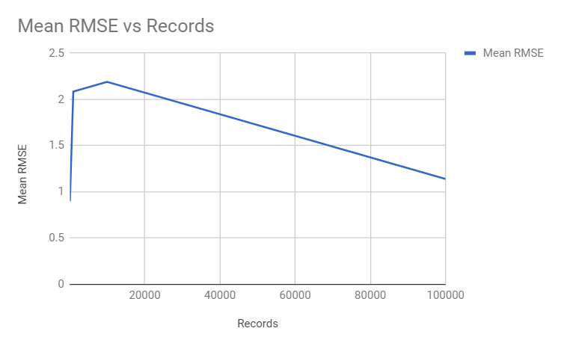

3) Records vs Memory

|  |  |  |  |  |
| --- | --- | --- | --- | --- |
| Records | 100 | 1000 | 10000 | 100000 |
| Memory (in BYTES) | 50903872 | 51020648 | 53604728 | 76095024 |

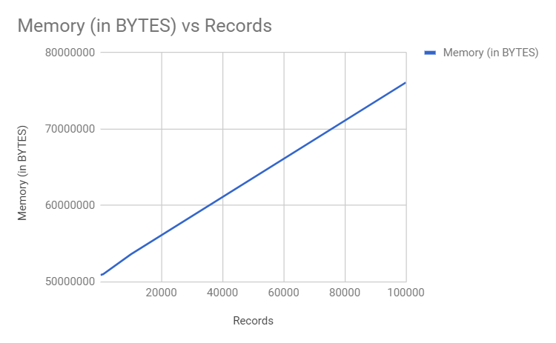

**KNN**

1. Records vs Time

|  |  |  |  |  |
| --- | --- | --- | --- | --- |
| Records | 100 | 1000 | 10000 | 100000 |
| Time | 0.007 | 0.0232 | 0.3151 | 12.358 |

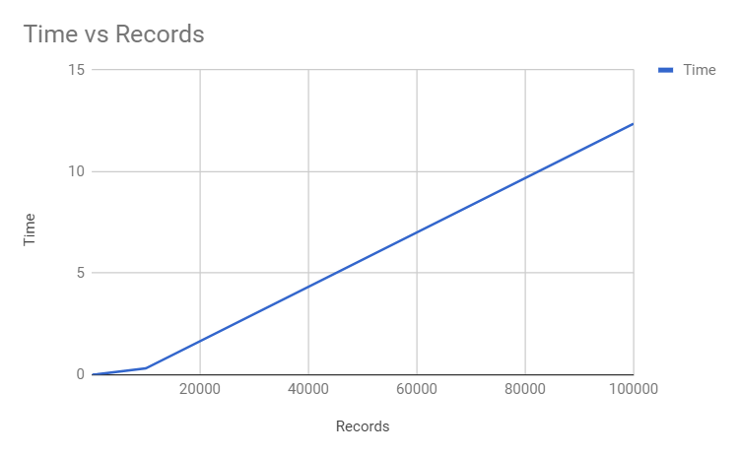

2) Records vs Mean RMSE

|  |  |  |  |  |
| --- | --- | --- | --- | --- |
| Records | 100 | 1000 | 10000 | 100000 |
| Mean Rmse | 0.85 | 1.0051 | 1.054 | 0.9826 |

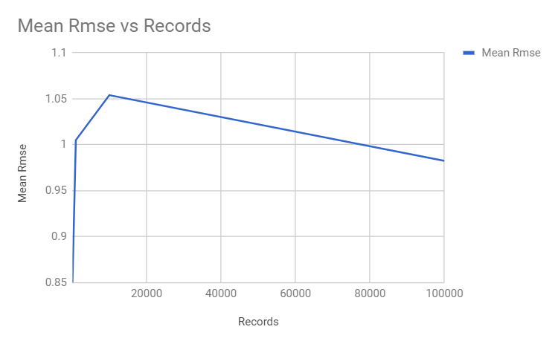

3) Records vs Memory

|  |  |  |  |  |
| --- | --- | --- | --- | --- |
| Records | 100 | 1000 | 10000 | 100000 |
| Memory (in BYTES) | 50894952 | 51009288 | 53597568 | 76084024 |

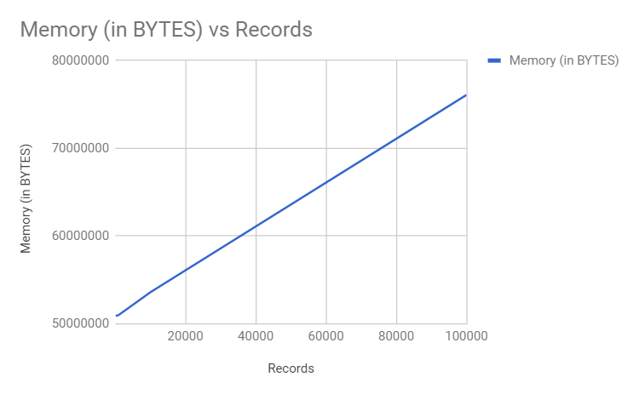

**SVD**

1. Records vs Time

|  |  |  |  |  |
| --- | --- | --- | --- | --- |
| Records | 100 | 1000 | 10000 | 100000 |
| Time | 0.01 | 0.09 | 0.97 | 7.59 |

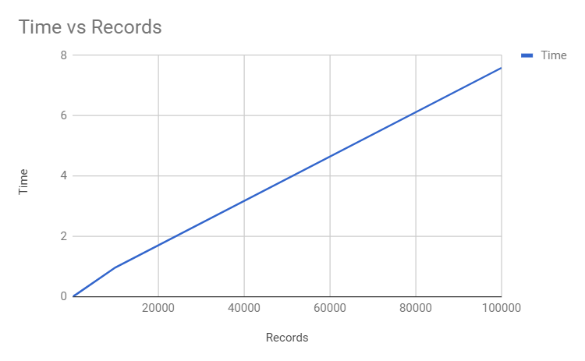

2) Records vs Mean Rmse

|  |  |  |  |  |
| --- | --- | --- | --- | --- |
| Records | 100 | 1000 | 10000 | 100000 |
| Mean RMSE | 0.8021 | 0.8801 | 0.9147 | 0.896 |

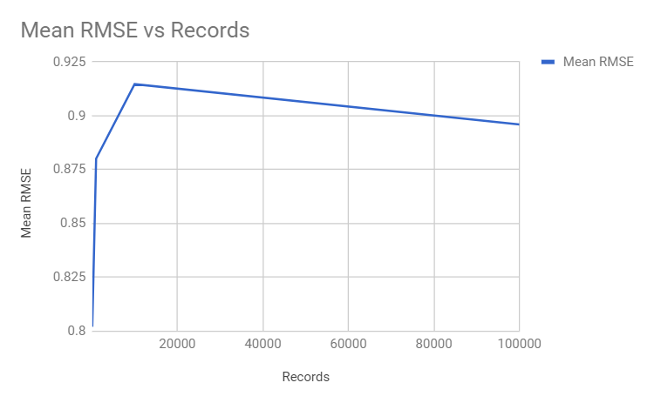

3) Records vs Memory

|  |  |  |  |  |
| --- | --- | --- | --- | --- |
| Records | 100 | 1000 | 10000 | 100000 |
| Memory (in BYTES) | 50872636 | 50776632 | 52096696 | 66467952 |

